Documentation

Institute Management System
Document Version: 2.0
Date: [Current Date]
Technology Stack: React (TypeScript), Tailwind CSS, Supabase
Authors: [Muhammad Hassan (23-st-044)]
Stakeholders: Educational Institutions, Administrators, Faculty, Students,

Table of Contents
- Introduction
- Overall Description
- System Features
- Non-Functional Requirements
- External Interface Requirements
- System Architecture
- Technology Implementation
- Appendices

1. Introduction

1.1 Purpose
The **Institute Management System** is a comprehensive, open-source web application designed to digitize and streamline administrative operations for educational institutions. This full-stack solution provides separate, responsive panels for students and administrators, enabling efficient management of academic records, attendance, course materials, and communication. The system leverages modern web technologies with React for the frontend and Supabase for backend services, ensuring scalability, security, and optimal user experience across all devices.

1.2 Scope
The system is a web-based platform for educational institutions using:
- Frontend: React with TypeScript and Tailwind CSS
- Backend: Supabase (PostgreSQL, Authentication, Storage, Realtime)

1.3 Problem Statement
Traditional educational institutions face several operational challenges:

- Manual Record Keeping: Student information, attendance, and grades are often
maintained physical registers or disparate digital files.
- Inefficient Communication: Lack of centralized communication channels between
administration, faculty, and students.
- Data Silos: Academic data is scattered across different departments without integration.
- Accessibility Issues: Students and parents often lack real-time access to academic
progress and institutional updates.
- Administrative Overhead: Manual processing of admissions, fee collection, and report
generation consumes significant resources.

1.4 Problem Solution
The Institute Management System addresses these challenges by providing:

- For Students:A responsive dashboard to view courses, attendance, grades, assignments, and communicate with faculty.
- For Administrators: A comprehensive panel to manage student records, faculty information, courses, schedules, fees, and generate reports.
- For Faculty:Tools to manage classes, record attendance, upload materials, and grade assignments.
- For Parents: Limited access to monitor their ward's academic progress and institutional communication.

1.5 Technology Definitions
Term | Technology | Purpose
React | Frontend Library | UI Components and State Management
TypeScript | Programming Language | Type Safety and Developer Experience
Tailwind CSS | CSS Framework | Responsive Design and Styling
Supabase | Backend-as-a-Service | Database, Auth, Storage, Realtime

1.6 References
- React Documentation: https://react.dev/
- Supabase Documentation: https://supabase.com/docs

2. Overall Description

2.1 Product Perspective

Project Simple Architecture Diagram
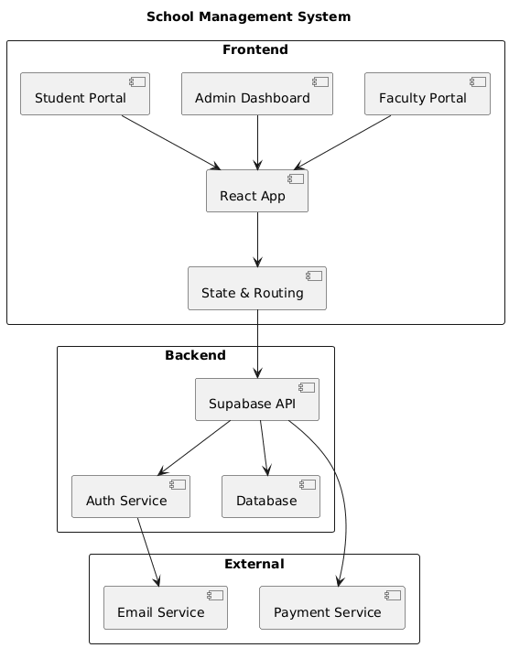

2.2 Product Functions
- React-Based User Interfaces
- Responsive components using Tailwind CSS
- Real-time updates with Supabase Realtime
- Form handling with React Hook Form
- Client-side routing with React Router
- Supabase Backend Services
- Built-in authentication and authorization
- File storage for documents and images
- Edge Functions for custom business logic
- Real-time Features
- Live attendance updates
- Instant notifications
- Real-time chat/messaging
- Live grade updates

3. System Features

3.1 Authentication System (Supabase Auth)

3.1.1 Description
Secure authentication using Supabase Auth with email/password and social providers.

3.1.2 Functional Requirements
ID | Requirement | React Implementation | Supabase Implementation
FR1.1 | User registration | React Hook Form + Zod validation | supabase.auth.signUp()
FR1.2 | Email verification | Loading state component | Supabase email templates
FR1.3 | User login | Protected route wrapper | supabase.auth.signInWithPassword()
FR1.4 | Google OAuth | OAuth button component | Google OAuth configuration
FR1.5 | Password reset | Forgot password form | supabase.auth.resetPasswordForEmail()
FR1.6 | Session management | React Context for auth state | JWT with refresh tokens
FR1.7 | Role-based routing | React Router guard components | RLS policies on tables
FR1.8 | Logout functionality | Clear auth context | supabase.auth.signOut()

3.2 Student Dashboard (React Components)

3.2.1 Description
Responsive dashboard for students with real-time data.
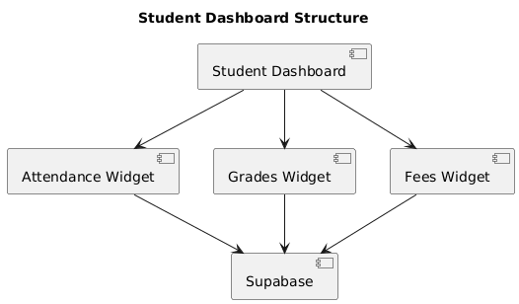

3.2.2 Functional Requirements
ID | Requirement | React Component | Supabase Query
FR2.1 | View attendance | AttendanceChart.tsx | select * from attendance where student_id = $1
FR2.2 | View grades | GradeCard.tsx | select * from grades where student_id = $1
FR2.3 | Submit assignments | AssignmentForm.tsx | supabase.storage.upload() + DB insert
FR2.4 | View courses | CourseCard.tsx | select * from courses join enrollments
FR2.5 | Pay fees online | PaymentForm.tsx | Edge Function + Stripe integration
FR2.6 | View notifications | NotificationBell.tsx | Realtime subscription to notifications

3.3 Admin Dashboard (React + Supabase)

3.3.1 Description
Comprehensive admin interface for managing the institution.
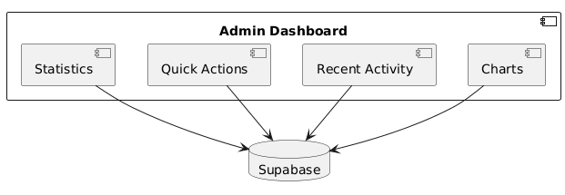

3.3.2 Functional Requirements
ID | Requirement | Technology Implementation
FR3.1 | Manage students | React Data Table + Supabase CRUD
FR3.2 | Manage faculty | React Form + Supabase users table
FR3.3 | Course management | Drag-and-drop + Supabase transactions
FR3.4 | Generate reports | React PDF generator + Supabase queries
FR3.5 | System settings | React Form + Supabase config table
FR3.6 | Bulk operations | CSV upload + Supabase Edge Functions

3.5 Grade Management System

3.5.1 Functional Requirements
ID | Requirement | React Component | Supabase Implementation
FR5.1 | Enter grades | GradeEntryForm.tsx | Bulk insert with transaction
FR5.2 | Calculate GPA | GPACalculator.tsx | PostgreSQL aggregate functions
FR5.3 | Generate report cards | ReportCard.tsx | Edge Function for PDF generation
FR5.4 | Grade analytics | GradeChart.tsx | Supabase analytics queries

4. Non-Functional Requirements

4.1 Performance Requirements
Requirement | React Implementation | Supabase Implementation
Page Load < 3s | Code splitting with React.lazy | Database indexing
API Response < 500ms | React Query caching | Query optimization
Real-time Updates < 1s | WebSocket connections | Supabase Realtime
File Upload Progress | Custom upload component | Supabase Storage with progress
Mobile Performance | Responsive Tailwind CSS | Optimized queries

4.2 Security Requirements
Requirement | React Implementation | Supabase Implementation
Authentication | Protected routes | Supabase Auth with JWT
Authorization | Role-based components | RLS policies
XSS Protection | React DOM sanitization | Input validation
CSRF Protection | Anti-CSRF tokens | SameSite cookies
Data Encryption | HTTPS enforced | SSL/TLS encryption
File Security | Signed URLs | Private storage buckets

4.3 Reliability Requirements
Requirement | Implementation Strategy
99.5% Uptime | Supabase SLA + Vercel CDN
Data Backup | Supabase daily backups
Error Recovery | React Error Boundaries
Data Consistency | PostgreSQL transactions
Failover | Supabase high availability

4.4 Usability Requirements
Requirement | React Implementation | Tailwind CSS Implementation
Responsive Design | Mobile-first components | Responsive utility classes
Accessibility | ARIA labels, keyboard nav | Focus states, color contrast
Loading States | Skeleton loaders | Animated transitions
Error Handling | Toast notifications | Error boundary UI
Form Validation | React Hook Form + Zod | Validation styles

5. Database Design & Schema

Detailed Table Definitions

5.1 Table: Profiles
Column | Type | Constraints | Description
id | UUID | PRIMARY KEY, FOREIGN KEY (auth.users) | User ID matching auth.users
email | TEXT | UNIQUE, NOT NULL | User email address
full_name | TEXT | NOT NULL | User's full name
phone | TEXT |  | Contact number
avatar_url | TEXT |  | Profile image URL
role | TEXT | NOT NULL | 'student', 'faculty', 'admin'
created_at | TIMESTAMPTZ | DEFAULT NOW() | Creation timestamp
updated_at | TIMESTAMPTZ | DEFAULT NOW() | Last update timestamp

5.2 Table: Students
Column | Type | Constraints | Description
id | UUID | PRIMARY KEY | Unique student ID
profile_id | UUID | FOREIGN KEY (profiles.id) | Reference to user profile
student_id | TEXT | UNIQUE, NOT NULL | Institution student ID
enrollment_date | DATE | NOT NULL | Date of enrollment
date_of_birth | DATE |  | Student's birth date
gender | TEXT |  | 'male', 'female', 'other'
address | TEXT |  | Residential address
parent_name | TEXT |  | Parent/Guardian name
parent_phone | TEXT |  | Parent contact number
parent_email | TEXT |  | Parent email address
current_class | TEXT |  | Current class/grade
section | TEXT |  | Class section
status | TEXT | DEFAULT 'active' | 'active', 'inactive', 'graduated'

5.3 Table: Faculty
Column | Type | Constraints | Description
id | UUID | PRIMARY KEY | Unique faculty ID
profile_id | UUID | FOREIGN KEY (profiles.id) | Reference to user profile
employee_id | TEXT | UNIQUE, NOT NULL | Institution employee ID
designation | TEXT | NOT NULL | 'professor', 'assistant', 'lecturer'
department | TEXT | NOT NULL | Teaching department
qualification | TEXT |  | Academic qualifications
specialization | TEXT |  | Area of specialization
hire_date | DATE | NOT NULL | Date of joining
salary_grade | TEXT |  | Salary scale/grade
status | TEXT | DEFAULT 'active' | 'active', 'inactive', 'on-leave'

5.4 Table: Courses
Column | Type | Constraints | Description
id | UUID | PRIMARY KEY | Unique course ID
course_code | TEXT | UNIQUE, NOT NULL | Course identifier
course_name | TEXT | NOT NULL | Full course name
description | TEXT |  | Course description
credits | INTEGER | DEFAULT 3 | Credit hours
department | TEXT |  | Offering department
semester | INTEGER |  | Semester number
faculty_id | UUID | FOREIGN KEY (faculty.id) | Assigned faculty
max_students | INTEGER |  | Maximum enrollment
current_enrollment | INTEGER | DEFAULT 0 | Current student count
status | TEXT | DEFAULT 'active' | 'active', 'inactive'

5.5 Table: Enrollment
Column | Type | Constraints | Description
id | UUID | PRIMARY KEY | Unique enrollment ID
student_id | UUID | FOREIGN KEY (students.id) | Student reference
course_id | UUID | FOREIGN KEY (courses.id) | Course reference
enrollment_date | DATE | DEFAULT NOW() | Date of enrollment
status | TEXT | DEFAULT 'enrolled' | 'enrolled', 'dropped', 'completed'
grade | TEXT |  | Final grade (A-F)
grade_points | DECIMAL |  | Calculated grade points

5.6 Table: Attendance
Column | Type | Constraints | Description
id | UUID | PRIMARY KEY | Unique attendance record
student_id | UUID | FOREIGN KEY (students.id) | Student reference
course_id | UUID | FOREIGN KEY (courses.id) | Course reference
date | DATE | NOT NULL | Attendance date
status | TEXT | NOT NULL | 'present', 'absent', 'late', 'excused'
recorded_by | UUID | FOREIGN KEY (faculty.id) | Faculty who recorded
remarks | TEXT |  | Additional notes

5.7 Table: Grades
Column | Type | Constraints | Description
id | UUID | PRIMARY KEY | Unique grade record
student_id | UUID | FOREIGN KEY (students.id) | Student reference
course_id | UUID | FOREIGN KEY (courses.id) | Course reference
assessment_type | TEXT | NOT NULL | 'exam', 'quiz', 'assignment', 'project'
assessment_name | TEXT | NOT NULL | Name of assessment
total_marks | DECIMAL | NOT NULL | Maximum possible marks
obtained_marks | DECIMAL | NOT NULL | Marks obtained
percentage | DECIMAL |  | Calculated percentage
grade | TEXT |  | Letter grade
submitted_by | UUID | FOREIGN KEY (faculty.id) | Grading faculty
submission_date | DATE | DEFAULT NOW() | Date graded

5.8 Table: Fees
Column | Type | Constraints | Description
id | UUID | PRIMARY KEY | Unique fee record
student_id | UUID | FOREIGN KEY (students.id) | Student reference
fee_type | TEXT | NOT NULL | 'tuition', 'exam', 'library', 'sports'
amount | DECIMAL | NOT NULL | Fee amount
due_date | DATE | NOT NULL | Payment due date
paid_amount | DECIMAL | DEFAULT 0 | Amount paid
payment_date | DATE |  | Date of payment
payment_method | TEXT |  | 'cash', 'card', 'online'
transaction_id | TEXT |  | Payment reference
status | TEXT | DEFAULT 'pending' | 'pending', 'paid', 'overdue'

5.9 Table: Timetable
Column | Type | Constraints | Description
id | UUID | PRIMARY KEY | Unique schedule ID
course_id | UUID | FOREIGN KEY (courses.id) | Course reference
faculty_id | UUID | FOREIGN KEY (faculty.id) | Faculty reference
day_of_week | INTEGER | NOT NULL | 0-6 (Sunday-Saturday)
start_time | TIME | NOT NULL | Class start time
end_time | TIME | NOT NULL | Class end time
room_number | TEXT |  | Classroom/lab
semester | TEXT |  | Academic semester
academic_year | TEXT |  | Current academic year

5.10 Table: Notices
Column | Type | Constraints | Description
id | UUID | PRIMARY KEY | Unique notice ID
title | TEXT | NOT NULL | Notice title
content | TEXT | NOT NULL | Detailed content
category | TEXT |  | 'academic', 'event', 'holiday', 'general'
published_by | UUID | FOREIGN KEY (profiles.id) | Publisher reference
target_audience | TEXT[] |  | ['students', 'faculty', 'all']
is_important | BOOLEAN | DEFAULT false | Priority flag
valid_from | DATE |  | Start date
valid_until | DATE |  | Expiry date
created_at | TIMESTAMPTZ | DEFAULT NOW() | Creation timestamp

6. System Architecture

6.1 High-Level Architecture
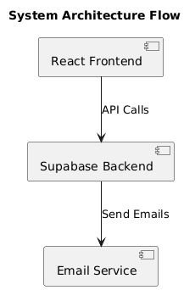

6.2 Data Flow Architecture
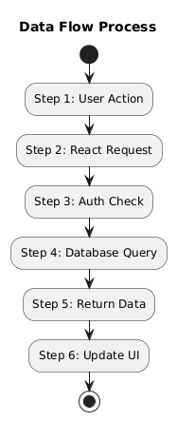

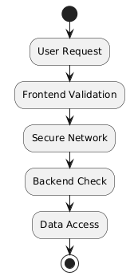
6.3 Security Architecture

7. Core User Flows

7.1 Student Panel Flow
- Login: Student logs in with credentials
- Dashboard: Views overview of attendance, grades, pending assignments
- Courses: Browse enrolled courses and subjects
- Attendance: View attendance history and percentage
- Assignments: Submit assignments and view feedback
- Grades: Check grades and academic progress
- Fees: View fee status and payment history
- Announcements: Read institutional announcements

7.2 Admin Panel Flow
- Login: Admin logs in with elevated privileges
- Dashboard: Institutional overview with key metrics
- Student Management: Add, edit, and manage student records
- Faculty Management: Manage faculty members and assignments
- Course Management: Create and manage courses and subjects
- Attendance Management: View and manage attendance reports
- Grade Management: Enter and manage student grades
- Fee Management: Manage fee structure and collections
- Announcements: Create and publish institutional announcements
- Reports: Generate various institutional reports

7.3 Faculty Panel Flow
- Login: Faculty member logs in
- Dashboard: View assigned subjects and classes
- Attendance: Mark daily attendance for students
- Assignments: Create and grade assignments
- Grades: Enter student grades
- Students: View student profiles and progress
- Materials: Upload course materials and resources

